April
Newsletter 2025

The Right to Repair, Or It Just Ain’t Fair
Written by Judith Wieber

At a recent online seminar hosted by NYAIL, moderated by Blaise Bryant, the following speakers formed a panel to educate us on an issue many users of wheelchairs face:
​​
- Alex Thompson, Director of Advocacy with NYAIL
- Shameka Andrews, Community Outreach Coordinator for Self-Advocacy Association of New York State: Capital/Hudson Valley Region
- Jean Minkel, Senior Vice President of Rehabilitation and Mobility Services for Independence Care System
The online seminar opened with Jean Minkel describing how wheelchair repair is not only episodic, but a constant worry. “Things seem to be getting worse rather than better.”

“Albany, we got a problem, and we need your help to solve it.”
Shameka Andrews also told her story about a two-month process to get her power chair fixed. It all started on November 1, 2024, on a trip home to Albany from New Jersey, when Shameka’s chair started to run at a snail’s pace when passing through Penn Station. Once in Albany, she had to wait until the next day to call the vendor, National Seating and Mobility, to make repairs.

“There is No Triple A for Wheelchairs”
Once the vendor was contacted, it was decided that the issue was the charger. The charger was replaced. A few weeks later, Shameka was now at the mall, and her wheels were not moving. The only thing she could do was go backwards. So, there she was going through the mall backwards, because it was the only way she can maneuver. She reached the food court, where the chair died. Mall personnel tried to help. They let her know that the chair felt very hot, and maybe the motor blew.

A person helping tried to get it on manual, so he could push Shameka out of the Colonie Center. Unfortunately, this did not work. Shameka then had to call a neighbor with a chair she could borrow. She had ordered a backup chair back in May of 2024, but still had not received it.

Again, this breakdown occurred on a Sunday where she must wait for the next day to get a hold of someone. The Vendor could not pick up the chair until the following Thursday. Stuck, she agreed. Thursday came, they arrived at the mall, but were not able to remove the chair. NSM did not have the right type of equipment. They would have to figure something else out, adding more time to this not getting resolved. They were also unable to give a time as to when they would be able to fix things.

Weeks passed without resolution, so Shameka reached out to social media. Shameka tagged her local newspaper, her local politicians, and her community. As a result, a physical therapist of hers read her post about her power chair dying at the mall, and how the chair had been sitting in the mall for two weeks. The physical therapist at once called the NSM and asked what was going on. The Vendor turned around and said they would have the chair to her the next day. When the vendor delivered the chair, he mentioned how the company had received lots of calls about the situation.

It was great that the chair was now home, but the battery and motor had to be replaced. After these parts were replaced, it was still not working properly due to incorrect installation of parts. As a result, Shameka, as of the date of this webinar, was still waiting for a new joystick and function box.

This was Shameka’s story, but there are many others with similar situations of long wait times and dealings with vendors not having parts, ordering the incorrect parts, and not properly addressing the repair.

Jean Minkel then addressed the question: Why is it getting so hard to get repairs on time?
There has been a definite change in the marketplace. In most of the country there has been an enormous consolidation of suppliers. In the past, a person using a wheelchair would have the contact information for local vendors and technicians. One would develop a rapport with their technician and give them a call when they ran into a problem.

Now vendors have been mostly consolidated into two main companies: National Seating and Mobility, and New Motion. Both companies are now private equity companies, which concentrate more on short term profits. The focus is on the sale of new high-tech rehab devices, which makes more money quickly. The profit margin is higher for new products, so repairs are not as lucrative. This consolidating seemed to start happening right before Covid, then when Covid hit, there were supply chain issues and breakdowns in repairs.

An underinvestment in repairs and technicians, and lack of inventory, have caused the disruption in service to the end users. There is truly a cascade of problems. Now they are doing ordering “in real time.” First diagnose the problem, then order the parts, then find out once the part arrives that it is the incorrect part for the problem. The local franchises are forced to follow their corporate rules.
Alex Thompson then discussed some of the different approaches being taken in other states around the country. He focused on three states: Colorado, Connecticut, and Massachusetts.

There was a landmark development in Colorado. Colorado passed a law having to do with the Right to Repair, and a companion law having to do with authorizations. The process to get an authorization is drawn out and convoluted. The Right to Repair Law empowers individuals and independent repair shops to get parts, and documentation to make repairs. The Colorado Medicaid program cut the need for prior authorization to help get things expedited.

Some states have limits on authorizations. For example, if the cost is $500 or less, the authorization is not necessary. As they are looking to improve things in New York, they are taking this into consideration. Hopefully, we’ll get rid of the hassle of authorization when obviously someone has been approved to use their chair and shown that the repairs are needed.

In the state of Connecticut, they created a commission which made a report addressing the concerns of consumers about the Medicaid program and private insurances. The Connecticut Report is very helpful in looking at the overall picture of what is happening. It looks as though Connecticut has taken a good look at all the aspects discussed here in this webinar, such as the possibility of using medical cabs to transport disabled power chairs, and what the timelines are between repairing a chair at a shop as opposed to repairing it at home.

Massachusetts is also working on legislation regarding warranty protections for consumers with disabilities, which would expand warranty coverage on all wheelchairs to two years. It holds providers to reasonable timelines for evaluations, and reimbursement to consumers for what they had to pay to get wheelchairs repaired. It would also require providers to stockpile parts to have them on hand, and authorize the Attorney General’s office to intervene when necessary.

Many of these states also have lemon law bills. In New York, if your chair is considered defective, there is an arbitration process wherein, if it is still within one year of purchase, you can get the Attorney General’s office to get your chair fixed, or a new chair.

But what can we do? If you can relate to any of these scenarios, or have a family member who can relate, or believe this is not right, then contact your local state representatives. Bring it to their attention that there is a bill in the Senate right now, S4500, that concerns you, and let them know of your personal experiences. The Assembly also has a companion bill, A6569, that needs co-sponsors.

Also, right now in the NYS budget, there is a line item asking for the funds to allow Medicaid to repair older powerchairs as a backup chair for when your primary chair has become disabled, and it is asking that powerchairs be serviced every 6 months, enabling a longer duration and dependable devices.
For people using chairs to ambulate, making them wait longer to get back to doing everyday things just is not fair. Let your representatives know that you support S4500 today.

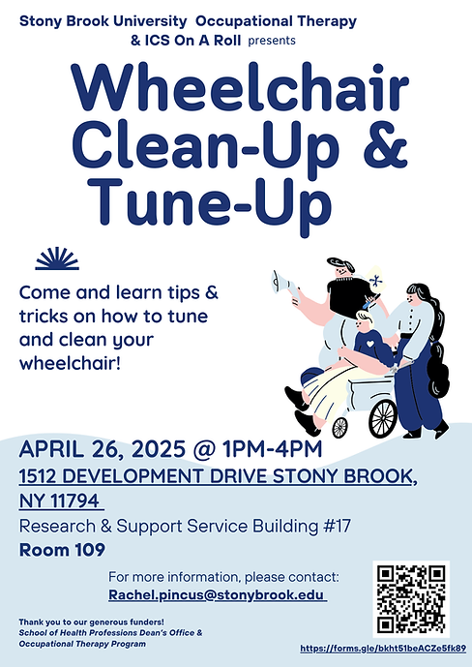

An Interview with Robin Mayr
Written by Judith Wieber
On a Sunday this past February, I had the opportunity to get to know and interview Robin Mayr. Robin is a former board member here at SILO and a grassroots activist and advocate for the blind and low-vision residents of New York. She also proposed a bill mandating that all major pharmacy chains provide accessible prescription labels in New York State. It was her own frustrating experiences and research which led her to a discussion with her New York State representative, State Senator Monica Martinez. After networking with many organizations of and for the blind and disabled, the framework for the bill was born.

Starting the interview, I asked Robin to tell me a little about herself. “I am married, I am blind/visually impaired, I have a daughter, and two grandchildren of whom I helped to care for. I am a retired social worker. Now I am an advocate, and I totally love it.”

Robin credits her love for healthcare and healthcare services, along with an internship at Head Start, as the foundation for her work in advocacy. “I worked at Head Start, which gave me a lot of what they call macro knowledge.” As an intern, Robin had overseen need assessment reports. “The work was fascinating, figuring out what the community needed and how to go about getting those needs met.”

Another accomplishment Robin shared was the work she had done in her undergraduate studies, as she prepared for her master’s in social work. The paper was entitled: “Healthy People 2010”. Robin chose to write about healthcare disparities in underserved populations, focusing on the healthcare system.

Back in 2016, while at Walgreens Pharmacy, Robin let the pharmacy know that she was visually impaired. The pharmacy asked if she would like large print, or braille labeling on her medication bottles. Robin let them know that she did not read braille, and it did not matter how large the font was, she could not see the print. The pharmacy then provided her with a ‘Walgreens Talking Pill Reminder’, a little button you could adhere to a medicine bottle that recorded up to 20 seconds of information. This would be good for knowing the name of the medicine, and how often to take it, but she and others with visual impairments would still need to get someone to record the information off the bottle. In addition, the button’s memory was extremely limited; it would be impossible to get all the information that people with vision have access to. Patient information, drug name, dosage, expiration date, order number, pharmacy number, drug interactions, side effects, number of refills, the doctor’s name, etc. This device would not suffice.

It is here where Robin’s prior work and education went into action, making many phone calls, and investigating the internet for accessible prescription drug labels. She learned about ScripTalk, manufactured by En-Vision America, and Spoken Rx. Both provide RFID (radio frequency identification) and text-to-speech technology. Here is where the difficulty arises. NOT ALL PHARMACIES provide this accessible labeling, including all important pertinent information, Walgreens being one such pharmacy. Robin then knew that we New Yorkers need it be mandated that all large pharmacy chains provide this reasonable accommodation.

(Here’s a link for information on ScripTalk’s apps and standalone device: https://www.envisionamerica.com/scriptalk-station-for-patients)

Robin called the Marketing and Industry Relations representative for ScripTalk, Sharla Glass. She spoke with The National Federation of the Blind, the American Council of the Blind of New York, the Alliance on Aging and Vision Loss, the Greater New York Council of the Blind, and the Council of Citizens with Low Vision International. She set up many meetings and discussions, providing the leg work and voice for not only the blind, but the print impaired population and elderly as well, making more people self-reliant, preventing people from going into nursing homes when they did not need to. “The bill has the potential to save 125,000 lives a year. It creates an opportunity for stronger independence… it follows fairness, justice, equity, and inclusion.”

Robin is proud of the advocacy work she has done. “I feel so honored to somehow been walked into this opportunity to do this… I think this issue is paramount for an Independent Living Center, such as Self-Initiated Living Options.” Everyone will win from passing this bill. “I know that I am doing the best job I can to improve the lives of others, but it takes teamwork.” Robin is interested in building teams, and finding partners to create change towards improvement.

Something I learned about Robin is that she has a twin sister, who unlike Robin does not have retinopathy of prematurity, the reason for Robin’s legal blindness. Robin’s favorite animal is the giraffe, and she owns a pair of giraffe slippers she got for Christmas. She is an avid reader of clean romance novels and human-interest books, along with books about health and health sciences. She reads at least one audiobook a day from the BARD National Library Service for the blind. Though political books are not usually her go-to, she just finished reading Citizen by Bill Clinton, and is currently reading Freedom by Angela Merkle, both books written by authors with strong feelings, which was her reason for choosing to read them. Playing iPhone word puzzles and card games with her grandson is another favorite pastime of Robin’s, such as Zannigrams, Woven Words, Word Pair, Letter Rooms, Kings Corner, and Cards to Go.

Another accomplishment that Robin is proud of is the input she had in creating an app for Estee Lauder. The app is called: Estee Lauder Voice-enabled Make-up Assistant, and is available on the Apple App Store and Google Play. It tells you if your foundation or eye shadow is on evenly, and if your lipstick is on correctly. The app is one of the tools Robin uses to look good and feel good, putting her best foot forward. In fact, a few years ago, Cosmopolitan featured the app in an article, and Robin was profiled.
Robin loves living on Long Island. “After living in Suffolk County for most of my life, I could not imagine living anywhere else and I don't understand why so many people who I have been close with all my life have moved off the island. To me it is a special place. And for people with disabilities, it is superior for a myriad of services, including transportation, which is not perfect, but it is among some of the best.”

I often like to conclude my interviews with the two following questions: Who are your role models, and what advice would you give to others living with a disability?

“Well, that's a hard question, one which I do not know how to answer. I suppose given my wonderful experience advocating with Senator Martinez on this bill, I would have to consider her at least in one of the top ten in my life. We have different role models for different reasons. My twin sister, who is my only sibling, is a role model because she has a huge heart and sometimes that is the most important thing you could have in your life.

“Our children are supposed to aspire to us. But my daughter is someone incredibly special. She has risen to the challenge of raising a child with a developmental disability while keeping true to herself. That takes a spirit that unfortunately, most of us tend to fall short on.

“And as for my grandson who has severe challenges in life, I would have to include him as one of my role models. Because whether he knows it or not, in my mind, he is perfection, no matter his challenges. I tell people that I keep him in my back pocket. He gives me strength every moment of the day.”

And the advice you would give a person living with a disability?

“It is not that we cannot do things, that the typical population can do, it is that we cannot do things in the same way. We all get intimidated; the minute we say we cannot, it becomes a self-fulfilling prophecy. It is not about the blindness; it is about how others are perceiving your blindness. Do not isolate yourself, and do not think you are less, because you are not. Learn the ways on how not to be a victim.

“Go out there and be a teacher! Do not buy into that ‘less than’ attitude. We can all have a pity party occasionally, but do not buy in to it. Put yourself back on track.”

It was a pleasure interviewing Robin. She is remarkably interesting, and her thoughts and words are unbelievably valuable. She is genuinely concerned about others and wants to do right by them. Thank you.

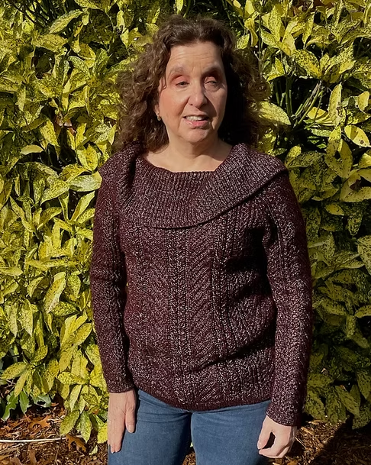

All or Nothing: Accessibility in Gaming
Written by Michael Kohut
The meteoric rise in popularity and relevance of video games in recent decades has made them more accessible than ever. The gaming industry now eclipses cinema in revenue and, like the publishing industry, provides the intellectual basis for many filmed phenomena.

After its 2023 premiere, “The Last of Us” became HBO’s most viewed debut season ever and did it in a two-month window. Over 30 million people were tuning in each week. “The Super Mario Bros. Movie” grossed 1.36 billion dollars in 2023. The entire global market for video gaming was valued at around 30 billion dollars in 2000. This year, it’s approaching 300 billion.

The cultural shift from niche hobby to filling cineplex lobbies offers new opportunity to connect with peers across oceans and generations. Wii bowling in nursing homes, “Among Us” connecting friends during the 2020 pandemic; gaming is typical.

For the disabled, a minority often defined and measured by how atypical we are, these games enable a kind of shared experience through activity that could be described as unprecedented. Forms of recreation in the past centered around doing - sports, marathons, festivals, travel - all required consideration by organizers and architects for the disabled to be included.

As a child, I always wanted to play wheelchair basketball, but there was no league, and few peers with interest. So, I settled for fighting games, such as Street Fighter, Super Smash Bros., Mortal Kombat, etc. Although I can’t move my left thumb fast enough to be a champion, I can instead apply my mind in a way that lets me compete with the general population. That feeling of equality, where my differences can almost be ignored, is rare and joyous.

But there is an ongoing problem in the video game industry. Disabled players, especially ones who aren’t trying to compete with other players, don’t want their limitations ignored, but find that they are, nonetheless. The variation in how accessibility features are treated by game publishers, developers, and hardware designers is about as broad as the spectrum of disability is.

In other words, accessibility features in gaming range from non-existent to all-encompassing. Usually, they fall somewhere in the middle, feeling like an afterthought in planning and development.

It’s not 2000 anymore. ‘Take what you can get’ is simply not acceptable as a design philosophy in an industry with no upper limit on accommodating disabilities. A paralyzed man received a brain implant in 2024 and made the news because the first thing he did was stay up all night using it to play Civilization VI. He could do it without the use of any of his extremities. It is 2025, and Nintendo is still releasing flagship titles without closed captions. We’ll explore this shocking disparity further in the “All and Nothing” series, comparing the attention, or lack thereof, being afforded to accessibility by companies and manufacturers across an industry that has no good excuse.

Dawn Cookler Takes Gold in Shot Put

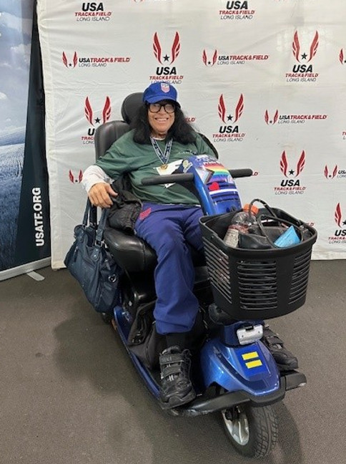
SILO Board Member, Dawn Cookler, wins a Gold Medal in Shot put at the USA Track and Field Indoor Championships with the Rolling Thunder Track and Field team on March 1st, 2025.​
Congratulations, Dawn!

Remembering The Capital Crawl
Written by Judith Wieber

In March of 1990, prior to the passing of the Americans with Disabilities Act, approximately 1,000 civil rights activists, ranging from wheelchair users to those with sensory disabilities, peacefully protested their frustration towards the inaccessibility of public buildings and other environmental barriers of all kinds.
​
This demonstration, organized by American Disabled for Accessible Public Transit (ADAPT), was known as the ‘Capital Crawl.’ The march started at the White House, went down Pennsylvania Avenue, and ended at the United States Capital Building. Many lifted themselves out of their wheelchairs, lowered themselves to the ground, and started to crawl up the steps of the Capital.
​
One very young person by the name of Jennifer Keelan, who at the time was only 8 years old, joined the adult activists. Her youth and her might attracted the attention of not only the press, but the attention of the legislators as well.
​
Their mission was to get the Americans with Disabilities Act passed. And passed it was, signed into law by President George H. W. Bush on July 26, 1990.

ADAPT Advocates in Albany: Demanding Accountability for CDPAP Transition

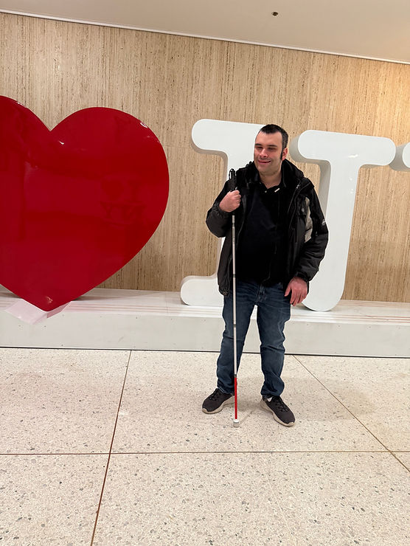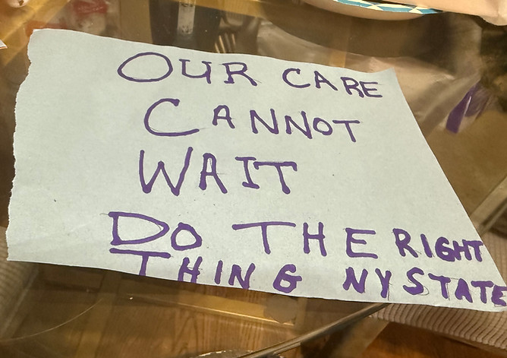
On March 23rd, 2025, SILO’s Peer Supervisor, Brandon Heinrich, traveled to Albany on behalf of Downstate New York ADAPT to participate in the crucial, Keys to the Community Campaign. Brandon joined fellow Adapt members, government officials and other advocates to voice the urgent concerns surrounding the State's disastrously rushed transition of the Consumer Directed Personal Assistance Program (CDPAP) to a single Fiscal Intermediary, Public Partnerships LLC (PPL). Despite months of warnings about the impending failures, the State offered only assurances that proved to be false, evidenced by the recent announcement of a "late registration window." Brandon's presence in Albany underscored Downstate New York Adapt's commitment to demanding accountability for this mishandled transition that threatens the vital care of countless individuals in our community.

Beyond Limitations: How Tenacity Fuels Success in Business
Written by Jillian Weston and Michael J. Kalberer

At Jillian's Circus, we believe that individuals are not defined by the limitations to their ability, but by the tenacity to overcome them. We've seen this firsthand in our work with incredible entrepreneurs, including one remarkable individual: Michael. Michael is blind, but his vision for his business is crystal clear. He's a gifted speaker, a natural communicator, and possessed of an unwavering drive that propels him forward. His story, and the stories of other entrepreneurs with disabilities, highlight both the unique challenges and the extraordinary potential that exists within this community.

As a digital marketing company, we’re in a unique position to witness the challenges and triumphs faced by business owners of all abilities. We’re also committed to creating opportunities for talented individuals of all abilities within our company. We utilize tools like DiSC assessments and work tests to strategically identify each employee's unique strengths and abilities, ensuring they are placed in roles where they can thrive. We believe in focusing on what can be done, not what can't.

Individuals with disabilities often face added hurdles, both in the workplace and as entrepreneurs. This is where Michael’s business, Michael J. Kalberer Presents, adds value. Michael J. Kalberer Presents is a company that utilizes the power of presentation to educate, inform, and entertain. Similarly to Jillian’s Circus, his company believes that ‘reasonable accommodation’ is not only a legal concept, but a social construct evolving around an attitude of acceptance. Fear of failure cannot be a deterrent; instead, the focus must be on finding solutions and communicating them effectively. Michael and Jillian believe that ‘Successful Accommodations Facilitate Excellence’. This means not just identifying a problem, but proactively presenting a solution to a boss, client, or vendor. Open communication and a willingness to adapt are key. In turn, business owners and clients can recognize these challenges and offer reasonable accommodations.

Our standard practice at Jillian's Circus involves email communication and monthly client check-in calls. However, recognizing Michael's unique needs, we adapted our approach to include weekly calls, ensuring consistent and effective communication. Furthermore, our commitment to accessibility extends to our physical workspace. We would never consider an office that wasn’t wheelchair accessible, understanding that physical accessibility is just as important as digital accessibility, and that’s how we get it done.

For more information on how our companies are shaping the world of inclusion, visit:
Michael J. Kalberer: https://www.michaeljkalbererpresents.com/
Jillian Circus: Home - Jillian's Circus
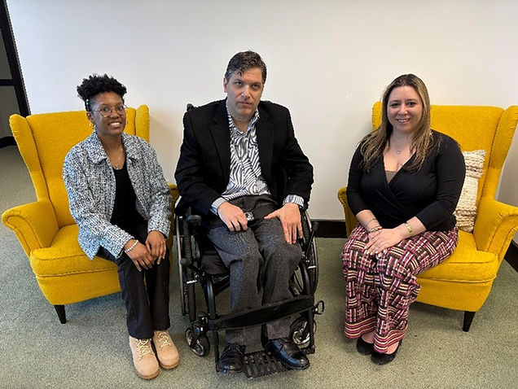

Congratulations, Codi Hill!
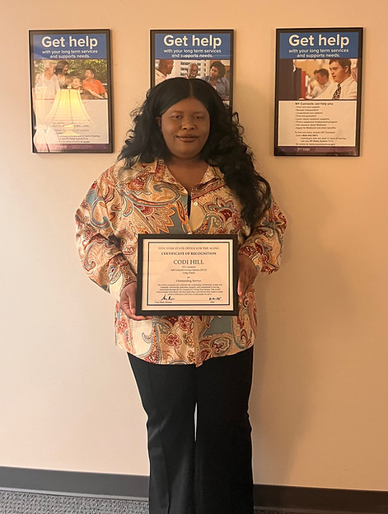
A round of applause for our Information and Assistance Specialist, Codi Hill! She received a well-deserved Certificate of Recognition from the NYS Office for the Aging for her outstanding work with the NY Connects Program. She goes above and beyond to connect people with vital resources and support. This recognition is a testament to her compassion and dedication. We're so lucky to have her!

Caregiver Support Group
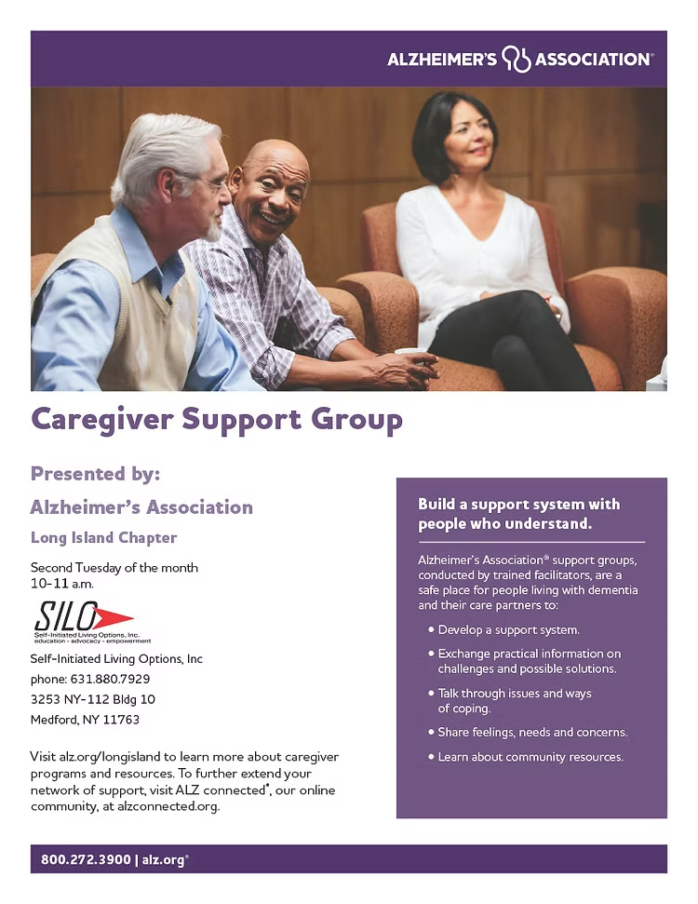
ALL Caregivers Welcome!
Contact Casey: clewis@siloinc.org

