June Newsletter 2023
SILO's Spring into Wellness Event
Written by Judy Wieber
SILO recently hosted a Health and Wellness Event under the direction of Kim Bjorklund and Erick Dreher, as well as our interns from Stony Brook University on May 2nd. Approximately 50 participants got an opportunity to listen and direct questions to a certified nutritionist and nurse practitioner, Puja Godhwani.

Although her experience and training has been in cardiology, inspired by her own children’s food allergies, and caring for cardiac patients going through the recovery process, she discovered a new passion, functional medicine. She spoke of how doctors are trained to treat our symptoms and not always trained to find the root of the problem. Representing the company All Star Infusions, Puja conveyed how important it is to pay close attention to what we are putting into our bodies.

The event started with some questions, testing our knowledge of what we understand healthy eating to mean. Puja explained how vitamin D, proteins, carb and sugar reduction, proper hydration, along with good fats all play a key role to giving our bodies the essential materials to prevent poor health. Improving our energy levels, will ultimately improve our quality of life, the goal.

Her talk was followed by a light and healthy lunch where we got to test our knowledge of stress and rest.
Once lunch was finished, we were guided through an all-inclusive chair yoga exercise by Tara Chianese of Cocomotion. Many reported feeling restored and refreshed after the 45-minute session, reinforcing a coping strategy to combat the stresses of everyday life whether you live with a disability or not.
The final speaker informed us of the different programs being held in Riverhead through the not-for-profit organization, RISE Life Services.
RISE grew out of the parent organization - Aid to the Developmentally Disabled, (ADD)formed in 1980. Concerned families sought support for their loved ones living in institutions. The New York State Office for People with Developmental Disabilities, and The New York State Office for Mental Health then came together to create ADD. Their belief was that a nurturing, person-centered environment would encourage a person’s emotional and physical sense of wellbeing to flourish.

The mission of RISE, as it states on their web site, is to encourage people of all abilities to rise to their greatest potential.

In 1984 RISE (Then ADD) started their first residential program in Riverhead, New York. Today RISE runs over thirty homes, providing case management, supportive apartments, residential programs, along with clinical supports.

The speaker addressed how they are actively seeking teen and young adults who are vulnerable and at elevated risk for suicide to provide them with excellent and enriching mental health services at their new clinic called Elevations. It was mentioned how SILO too will soon be opening a multi service mental health clinic this September, plans are in the works for both agencies to work to serve Long Islanders with the highest mental health supports in the least restrictive settings.

The event closed with a mindfulness and meditation exercise. A chime was rung, and participants were asked to raise their hands when they could no longer hear the chime. This was done to focus and heighten a person’s awareness. Then a recording which walked us all through how to use our breath and minds to visualize positivity.
I personally found the event to be refreshing. I also felt thankful for the experience and glad that I now have a few more “tools” for my “health and wellness toolbox.”

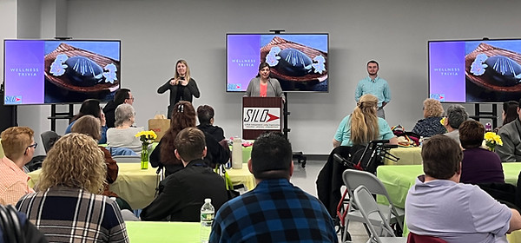
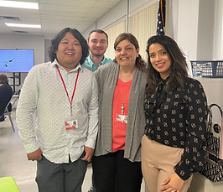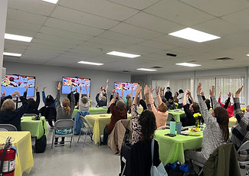

May was Older Americans Month
Older Americans Month is a time to celebrate the vital role that older adults play in our society. Throughout history, older adults have made significant contributions to our communities, families, and workplaces. They have lived through times of war and peace and have seen the world change in countless ways.

In May, we recognize the significant role that older adults play in our society, and we celebrate their contributions. From volunteering in their communities to mentoring younger generations, older adults are making a positive impact on the world around them. They bring a wealth of knowledge, experience, and wisdom to every aspect of life.

Older Americans Month is also a time to focus on the challenges that older adults face. Many older adults struggle with issues like social isolation, financial insecurity, and health problems. We must work together to support older adults and ensure that they have access to the resources and support they need to live healthy, fulfilling lives.

Each May, be sure to take the time to honor and celebrate the older adults in our lives. Whether it is a grandparent, neighbor, or friend, let us show them how much we appreciate their contributions and the impact they have on our world. Let us also work together to address the challenges that older adults face and ensure that they have the support they need to thrive.

Older Americans Month is a time to celebrate the past, present, and future contributions of older adults, and to recognize the key role they play in our society.

Some notable older Americans and their accomplishments include:
- Ruth Bader Ginsburg, who served as a Supreme Court Justice until her death at age 87
- Stan Lee, who created many of Marvel Comics' most iconic characters and continued to work in the industry until his death at age 95
- Betty White, who continued to act and make people laugh well into her nineties
- John Glenn, who became the oldest person to travel to space at age 77
- Frank Lloyd Wright, who continued to design buildings until his death at age 91.
- Grandma Moses, who began painting in her seventies and became a famous artist
- Benjamin Franklin, who was one of the Founding Fathers of the United States and continued to make scientific discoveries well into his eighties
- Laura Ingalls Wilder, who began writing the "Little House" books in her sixties and continued to write until her death at age 90
- Celia Cruz, who continued to perform and record music until her death at age 77
- Colonel Sanders, who founded Kentucky Fried Chicken in his sixties and continued to be the face of the company until his death at age 90.
- Julia Child, who published her first cookbook at age 50 and went on to become a beloved TV personality and culinary icon
- Norman Lear, who created some of the most iconic TV shows of the 20th century, including "All in the Family" and "The Jeffersons," and continued to work in the industry well into his 90s
- Maya Angelou, who published some of her most famous works, including "I Know Why the Caged Bird Sings," in her forties and continued to write and speak until her death at age 86.

Considering Older Americans Month and the special needs that face older Americans, Laurie Delgado SILO’S Community Engagement Officer and Jill Cuyar, Chief Communication Officer recently attended the Nassau County Office for the Aging Annual Older Americans Month conference in Uniondale where they gathered some information about an organization called “Rebuilding Together - Long Island” A not-for-profit organization consisting of volunteers who help with repairs and rehabilitation of homes of elderly and disabled. They have helped with things from changing a light bulb to snow removal, and more. Contact SILO’s NY Connects line: 631-730-3737 for more information regarding this resource, and to inquire about other community services for our older Americans.

Coming Soon...
Written by Judy Wieber
SILO will be opening an “all under one roof” comprehensive, mental health counseling center.

SILO’s Counseling Center: Pathway to Wellness, will be opening later this year. The center will be staffed with certified and licensed practitioners, under the direction of Kim Bjorklund, LCSW.

Practitioners will be prepared to meet our folks in person, using a “strengths-based approach,” to help strengthen participants through therapy.

Medicare, Medicaid, and most private insurances will be accepted.

If you find you or someone you know is in need of counseling, or if you have any questions about SILO’S upcoming counseling center, please give Kim Bjorklund a call at: (631) 880-7929 ext. 165.

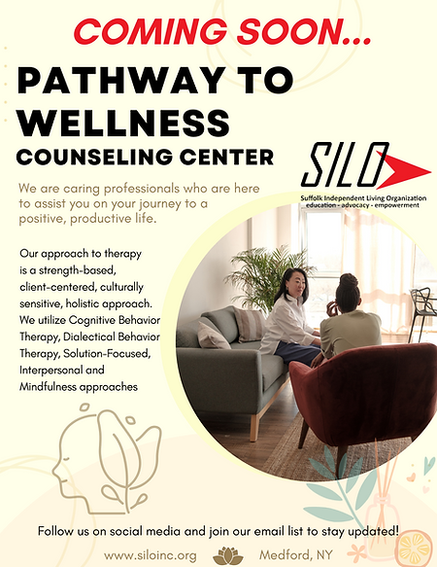

Kim Bjorklund, LCSW, has her Heart in the Right Place
Written by Judy Wieber
Kim a mother of two, and twin boys on the way with her wife, Amanda, is motivated by her love of her children, family, and finding fulfillment in the work she does. Her mission is to provide excellent quality mental health services. “I want those that seek our help to know they are people who may be struggling with things, but their life situation can change for the better. All people, no matter what their life circumstances, can achieve what they are seeking out of life. Life always provides new chances and new opportunities.

At a young age, Kim remembers encouraging a young boy with a developmental disability to laugh and have some fun. The child’s mother was so happy to see him smile. Kim knew there and then, helping others and seeing them happy brought her joy as well.

When I asked Kim, “What kinds of things do you like to do in your spare time?” Kim responded, “I am the kind of person who enjoys work. One of my mantras is: Say yes and figure it out later. When I decide to do something, I jump in one hundred percent,” a trait she credits inheriting from her dad. She does enjoy gardening, decorating and music of all kinds. She also loves to volunteer.

In 2010 to 2011 Kim volunteered at a summer camp for kids with cancer, established by the American Cancer Society (ACS). Unfortunately, in 2011, ACS, due to budget cutbacks, had to cut the summer camp program out of the budget. Kim and her friend Melissa could not allow this to happen. They picked up the ball and ran with it. Together they started a new nonprofit, “Kids Need More.” Through hard work, perseverance, and tons of fund raising, the summer camp experience was back afloat.
​
Although Kim is no longer part of Kids Need More, the organization is still in existence today. Kim is proud that it is still giving new chances and opportunities for healing through fun and friendship. “The camp helped me to see what is important in life, the experience gave me a true sense of purpose and fulfillment.”

Equipped with an undergraduate degree in Psychology and Sociology, and a master’s degree in Human Resources, Kim was prepared for a career in Mental Health Administration, but then realized becoming a Social Worker was really her calling. Kim redirected herself back to Stony Brook to get her second master’s in social work, which she received in 2014.

In 2017 Kim, wanting to advance from her private practice as a mental health therapist, joined the SILO team. She later became field supervisor for social work student interns at SILO and the Director of SILO’S Peer Integration Program.
​
Kim is looking forward to transitioning to the Director of SILO’S Pathway to Wellness mental health counseling center, opening later this year. “With our society desperately needing excellent mental health care, I know we can make a difference in this underserved community.” Feeling very privileged for the knowledge and cumulative experiences she has had, she wants for those receiving services to know that they will be provided with kindness, understanding, and the resources to live independently. They will not be treated like just another case going through a revolving door. Here they will be greeted with a sense of welcome and purpose.

Kim’s daughter, Kathryn, 24, is going to be working on her PhD at Duke University in the field of Neuroscience research. She is currently working there researching the effects of serious pediatric health conditions and how it effects the brain. Her son AJ is an EMT and a current student at Suffolk Community College’s Nursing program. He is looking forward to becoming a nurse and working in the Pediatric Emergency Room.

Kim also credits three people who have played important roles in helping to mold her into the person she is today: her third grade teacher, Mrs. Bucalo. “I always wanted to be like her. She was caring and encouraging.” Her eleventh-grade history teacher, Mr. Varajaro. “I always respected and admired him. He was the kind of teacher that never let you fall, even when things were hard.” And the third, and most important person is her dad, a good man, who has struggled with Retinitis Pigmentosa (RP) for most of his adult life. He was a real go-getter in his early years, always giving his all to everything he did. “He taught me about kindness, empathy for others, and how to live life.”
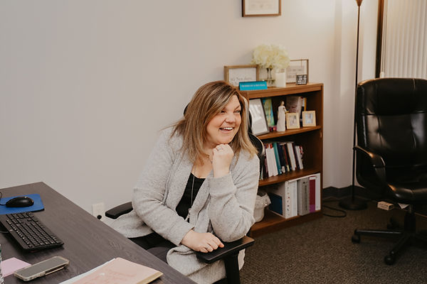

Article: Celebrating the life of Sally Johnston
https://cdpaanys.org/2023/05/16/celebrating-the-life-of-sally-johnston/

Generative AI
Written by Judy Wieber
Are you ready for Artificial Intelligence? I hope so, because it has arrived.
Recently while attending Legislative Advocacy Day in Albany, our CEO Joseph Delgado gathered information about a generative artificial intelligence platform used to match job seekers with disabilities to jobs best matching their abilities. This platform will not only help match jobseekers with jobs, but will also help employers test their websites for legal accessibility compliance, enabling employers to demonstrate their commitment to equal opportunity hiring.
Meet Jobability, created by Our Ability Inc. Visit their website at: www.ourability.com
Speaking of Generative AI, can you tell which article in this newsletter used a generative artificial intelligence writing tool to help create the article?

Fentanyl is Killing Many
Written by Judy Wieber
According to the DreamScape Foundation, 20% of Americans have a disability. 65% of this population of people who are of working age, are not employed. We all know how unemployment leads to poverty, homelessness, and diminished quality of life, making our community at risk for drug use.

People are dying due to the misuse of prescription and illegal drugs. If that is not bad enough, these street drugs are being laced with Fentanyl. Fentanyl poisoning is killing many; not only the person using, but the people trying to save people from fentanyl overdoses. It is affecting the young, the elderly, the poor, the rich, the disabled. All need to take this epidemic seriously.

May 9 was Fentanyl Awareness Day. In an effort to cut down on the deaths imposed by fentanyl, the not-for-profit organization: Community Action for Social Justice provides to those who would like them, Fentanyl test kits, free of charge, no questions asked. The kits come equipped with information on how to contact resources for help when a person is ready and has decided to stop usage or address addiction.

The mission of Community Action for Social Justice is to improve the lives and health of Long Islanders who have experienced the repercussions of drug use, incarceration, and homelessness. They are looking to meet community members where they are and allow them to make decisions for themselves.
​
SILO, with the help of CASJ, can also provide kits to those who would like one. Contact (631) 730-3737 for more information.

SILO's 2023 Americans with Disabilities Act Celebration
Save the Date!

Promotional Tables and Sponsorship Opportunities



