December 2022 Newsletter

International Day of Persons with Disabilities
Article by Judy Wieber
December 3rd is International Day of Persons with Disabilities. I do not believe we have any parades, or celebrations specifically, but I wonder what a celebration might look like? Imagine with me, a parade.
The Macy’s Thanksgiving Day Parade marches down 6th Avenue Manhattan with all its balloons, floats, and bands. It is quite a spectacular event. The Rose Parade marches down the streets of Pasadena, California with beautiful floats made of roses. Persons with disabilities too, can celebrate our communities’ accomplishments with the same magnitude and pride.
If we are picturing in our mind’s eye what an International Day of Persons with Disabilities looks like, let’s imagine our parade in sunny Orlando Florida, right in the heart of Disney, it’s December 3rd after all.
Perhaps we could get Stevie Wonder to sit upon a float and play us some songs. We could have Daniel Jacob Radcliff, dressed as Harry Potter or Tom Cruz in his Top Gun flight jacket walking along the street, greeting fans. Both men diagnosed with learning disabilities at a young age. Marlee Matlin signing on a float the words to a song, or a huge balloon of Rae Charles and Christopher Reeves, flying overhead. A float designed to represent Helen Keller and Ed Robert, the father of the Independent Living Movement, could be next.
A parade in downtown Orlando just wouldn’t be right without Disney being present. We could have Disney’s first princess with a disability, Elsa, as Grand Marshall. Vanellope von Schweetz, from Wreck It Ralph, Dory from Finding Nemo, and Ariel from The Little Mermaid, longing to be part of the walking world. Of course, Mickey and Minnie could join the parade, adding to the “magic” of the day. I can picture it, Flying balloons of Ameer, Julia, and Jason, all Sesame Street Muppets with disabilities.
Movie cast members of phenomenal movies, portraying life stories of persons with disabilities, marching up the street might delight the crowds. Shia LeBouf and Zack Gottsagen, who starred in the Peanut Butter Falcon, would make a good pick. The cast members of The Theory of Everything, Crip Camp, Breathe, I am Sam, Still Alice, would represent outstanding stories. another movie favorite: Walk Ride Rodeo with Amberley Snyder up on top of her horse. I can picture Amelia Jones and the entire cast of Academy Award winning film for best picture in 2021, Coda.
What would a parade be without a marching band? Meet: F.R.E.E. Drum and Bugle Band, who’s 70 members have “different abilities” https://www.youtube.com/watch?v=bx1nRtlWsfk. Based here on Long Island, in Old Bethpage, New York, the band made world history in 2016 when they competed as the first bugle drum band made of its kind.
Sophie Morgan, you might recognize her from an ad for Adidas sportswear, or from Channel NBC News presenting for the 2021 Summer Para Olympics held in Tokyo. A native of England, Sophie is acclaimed as being one of the UK’S most influential people with a disability. She would make an excellent presenter.
Our parade might be fun to think about, and who knows, maybe a reality in the future. Regardless, the community of people with disabilities must celebrate their accomplishments. Though there is still more we can do, we have come a long way, so let’s celebrate!
White Cane Safety and Awareness Day
Article by Jill Cuyar
In acknowledgement of White Cane Safety Day this past October, SILO held 3 mini-workshops for SILO staff, instructed separately by Marilyn Tucci, Judy Wieber and Ecaterina Henter.
These workshops reviewed the history of the white cane, proper techniques and usage of the white cane, and how to properly and respectfully guide or assist someone with a visual impairment/blindness.
Staff were then partnered up and took turns being blindfolded while attempting to use the cane techniques around the office, in order to experience how it feels to navigate with a cane when you are unable to see. Their partner was instructed to stay near and respectfully offer assistance as needed.
After this workshop experience, staff reported having more respect and understanding for those with a visual impairment/blindness and felt more confident in ways they could offer assistance going forward.
This exercise also demonstrated that even if you acquire a disability, you are still the SAME person, and are just as VALUABLE, IMPORTANT, and WORTHY OF RESPECT than ever!
The following are some comments from our staff after the experience:
Thank you for coordinating this event! It was a wonderful learning experience.
For me, I kept thinking: Thank God I’ve walked these halls hundreds of times! I wondered what it would be like to navigate new places in my community.
I am grateful to have had this experience.
-Brianna Tesoriero, LMSW
I really enjoyed participating on White Cane Day. It was not only very educational, but also made me aware on how to approach someone who is legally blind. Right when I began walking with the blindfold – I felt my legs go shaky due to the unknown of what was around me. I definitely think this is a great activity to continue on having every year. Thank you!!
-Maria Vanegas
White cane day was a terrific and terrifying experience. As the daughter of a blind man, I can tell you that being blind was scary for me and very disorienting. I too am happy that I knew the layout of the building.
It was a fantastic experience.
-Kim Bjorklund, LCSW
I really enjoyed the White Cane Day Workshop! The experience was Amazing! I have a new found respect for people with visual impairments. I was so surprised to actually feel the difference around me going from the hallway to the lobby area. I could actually feel the larger space. I’m so very glad that I participated. Thank you.
-Venesa Arroyo
During the exercise I felt scared, I could not believe how dark everything felt. Thank you for conducting this for us!
-Nicole Johnson
First, I want to thank you for the opportunity to experience the White Cane. The moment I put the blind fold on, I immediately said, “OMG it’s really dark” and thought about how grateful I am to be able to see. That’s a blessing that we take for granted daily. Walking in the shoes of Judith, Marilyn and Ecaterina for a couple of minutes made me appreciate their hard work even more than before. I am super proud of them.
Thank you again.
-Taciana Cheriel
For me, while blindfolded, I kept thinking, I’m glad I’m very familiar with the layout of this building and I noticed more sounds and even room temperature changes than I usually do walking down a hall.
After this workshop, I now feel more comfortable and confident offering guidance or assistance and am truly impressed by anyone who navigates places they are not familiar with, or even places they ARE familiar with. When blindfolded, my only comfort was knowing I had a coworker making sure I didn’t get lost or hurt. That is not something most white cane users have available at all times, so it was really a humbling experience.
-Jill Cuyar
The workshop was very informative. I was unaware of the different cane movements that are key for navigating while at home and in the community. It was very interesting having to rely on my other senses such as hearing and touch while exploring the building. So Happy to be a part of this workshop!
Thank you,
-Kathryn Celentano
First and foremost, it was a great idea to educate people working in this organization what visually impaired individuals deal with daily.
Ecaterina’s introduction helped in more than one way and raised awareness on many things that we take for granted.
While blindfolded I tried to keep in mind what Ecaterina had shown us. I started my walk around the building in Anna’s room. Maneuvering the cane takes skill. This is the first thing that I realized. How far to keep it in front of you and how far to move it from side to side. As I walked from Anna’s room to the kitchen I sensed the different smell and the narrowness of the door frame. Going into the office area I became aware of the difference in temperature and the texture of the flooring, as this was now a rug. It was harder for me to roll the cane on the rug, but I felt less afraid of perhaps slipping. Sounds were different when in a more open area vs a close one. Although I have seen all the areas where I was now walking, it was hard to direct my body in the right direction. I can’t imagine what it would be like walking in a place you have never seen, crossing a parking lot or trying to find the entrance of a building. This experience has had me thinking about the daily challenges these folks face from one minute to the next. Can’t think of a better way to have had SILO employees experience and learn than to put them in their shoes.
Would love to hear what other people experienced.
-Martha Vargas
I want to thank everyone who participated, for being a good sport. The experience can be very humbling and nerve racking, so I want to thank you for letting go of any concerns, fears you may have had; and being open to the experience. I got to play the role of teacher, so that did wonders for my self-esteem, thank you. I hope the experience helps to answer any questions one may have on how to approach, and assist a person with low vision, or no vision. We all touch each others lives, as the saying goes, “no man is an island.” So whether it should put a person at ease on how to assist at SILO, or in our communities, others will observe and also learn from your interactions.
-Judy Wieber
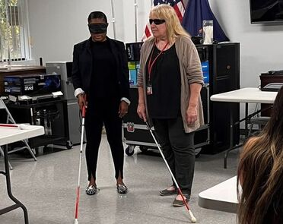

Robotic Support Animals
Article by Judy Wieber
With the Holiday season soon upon us, and loneliness being a chronic hardship for many, the Suffolk County Office of the Aging recently found a temporary home for two purrfect pets with a very important job.
Meet Kitty and Siley, a fluffy gray and white kitty, and soft adorable golden retriever puppy. The interesting feature about Kitty and Siley is that they are robotic. Kitty purrs, meows, rolls on her back. Her eyes blink, and she interacts with you as if she were alive. Siley as well, barks, pants and moves his eyes. Evidence has shown these low maintenance companions have helped persons with Alzheimers, dementia, social isolation and loneliness.
Do you know anyone who might provide a furever home for one of these friendly furry pals? To learn more contact SILO, OR visit the joyforall.com website.
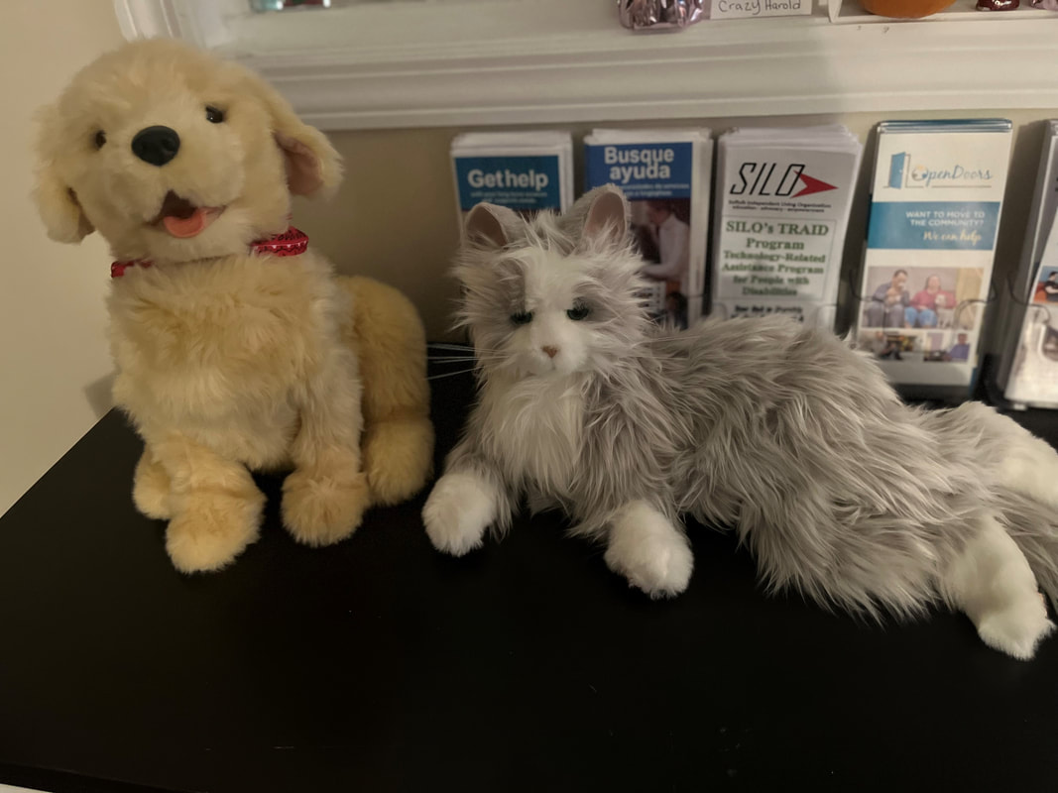
WWW.JOYFORALL.COM

Christmas Dinner Gathering
Written by Jill Cuyar
Theresa Pearl, founder of Long Islanders Helping Long Islanders, a Facebook group designed to help share resources and lend a helping hand on Long Island, is hosting a Christmas Dinner Gathering on Friday, December 23rd 2022 in Centereach, from 4pm-8pm, at 31 Horseblock Rd, Centereach, NY 11720 (Connect Church). This is the very first year the group will be hosting this event but hoping to continue to do so each year forward.
Members of the Long Islanders Helping Long Islanders will be buying or cooking the food being served and volunteers are delivering meals to those who consider themselves medically frail or homebound. Volunteers are willing to carpool, if needed, making their best effort to ensure guests are able to attend if they choose to do so. Theresa informed us that this event will be held at Connect Church, which does not have any stairs inside or outside the church for accessibility purposes. This Christmas Dinner Gathering will also offer a chance to win prizes, including a free raffle.
If you’d like to reserve your seat or have any questions about this event, please email LongIslandershelpinglongisland@gmail.com or call Theresa: 631-627-2946
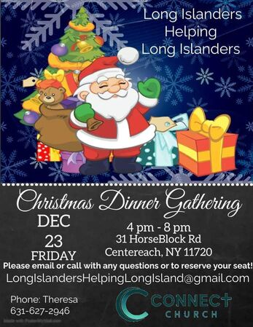

It’s The Law, Communication is a Two-Way Street
Article by Judy Wieber
SILO participated in helping the Town of Islip Disability Advisory Board break down barriers of communication recently, sponsoring an American Sign Language Interpreter at a press release held at the Suffolk County Sheriff’s Office, in conjunction with the Town of Islip Supervisor, Angie Carpenter and Town Councilman, Jim O’Connor, chair of the Disability Advisory Committee.
The Suffolk County Sheriff’s Office became the first in the county to equip all deputy sheriffs with “Palm Communication Cards” designed with the 40,000 deaf and hard of hearing residents in mind, explained Sheriff Toulon. The cards are abiding by Title II of the ADA, making communication with a motorist who is deaf or hard of hearing comprehensive, quick, and clear.
When motorists are pulled over, they are usually asked to supply their license/identification, registration, and if they know the reason for being pulled over. A person who cannot read lips or hear the voice of the officer may be confused and intimidated, and unable to communicate effectively. The “Palm Communication Cards” should serve to clear the lines of communication, protecting a person’s rights and dignity. The cards also allow motorists to explain their situation. Perhaps the motorist has run out of gas, on their way to the hospital, or need directions. The cards, when presented to the driver, can help alleviate fear and can be a very quick means to convey a situation.
The Sheriff’s Office hopes other first responders will follow suit, adapting cards to fit the circumstances surrounding the people they serve and protect.
All municipalities publicly thanked constituency for making them aware of their needs, so to make their work more effective.
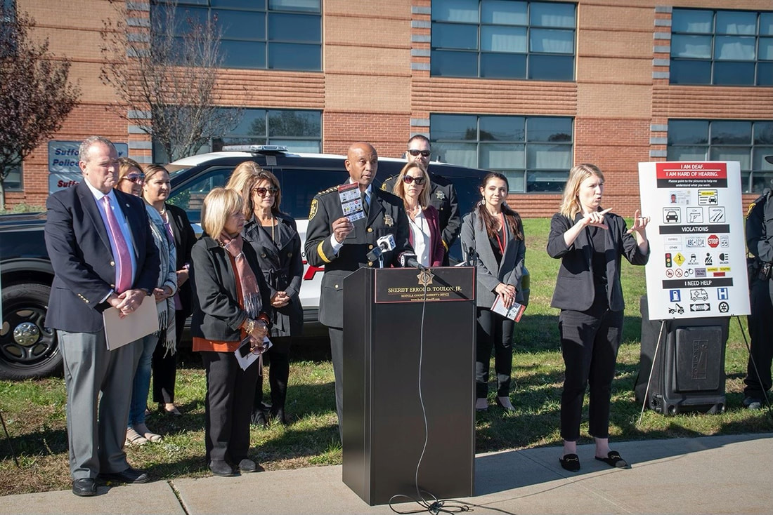

Fried Apples Recipe
Article by Judy Wieber
Recipe from Melissa Jackowski
When I put out the call for any recipes for the newsletter, Melissa came right to the rescue. She told me she not only loves to cook, but she takes cooking classes as well.

I asked her if she might have a holiday favorite to share, she responded with one of her favorites, fried apples. This recipe is quick and easy to make and not too bad on the calories.

As a person with a disability Melissa adapts her baking station by first, making sure she has a pair of tongs to transfer food, she keeps food on her stronger side, so it is quicker and easier to reach. She uses a large spoon instead of a whisk, and she uses dycem, to help hold items in place. .

I let her know of how I wasn’t familiar with dycem. Dycem is a non-slip piece of material used by people with weak hands. The material allows the baker to secure the bowl, pan, cup, preventing them from dropping, and accidentally pushing off the countertop. It enables a better grip on things. The material itself is light weight and can be cut into sheets, or different shapes, and is very practical to use in the kitchen.

This recipe should take about 30 minutes to make or a little longer and it makes about ten servings, so it is nice for a small gathering. You want to prepare 2 pounds of peeled and cored golden delicious apples, approximately four apples. You can use honey gold, Cortland, granny Smith, or any you prefer. Some apples are better for baking than others. The above mentioned seem to stay firm during the baking process while the Macintosh and red delicious should be avoided since they tend to get mushier.

Once they have been peeled and cored, you need to cut them into ¾” inch wedges. Prepare a 12” skillet with three teaspoons of unsalted butter Place butter in skillet and melt. Over a medium heat.

Mix in a medium size bowl: 1/4 cup granulated sugar, 2 Tablespoons packed light brown sugar, 1 Teaspoon ground cinnamon, 1/4 Teaspoon ground nutmeg. (Optional walnut and raisins could be added) once the butter is melted. Add the sugar, apples, and spices to the pan. Mix with a large spoon, Cover for about 14 minutes, checking and stirring occasionally until the apples are tender. Using the tongs, remove the contents of the pan to a serving dish. Now take a half cup of apple cider, and 1 tablespoon of corn starch and mix thoroughly with a whisk, or large spoon in a small cup, add to buttered skillet over medium heat. Watch for thickening. Constantly stir and simmer for about thirty to 60 seconds. Once the sauce has thickened, pour over the apples and serve with whipped cream or vanilla ice cream.
-------------------
On Friday, October 14, 2022, SILO hosted its annual Self Advocacy Conference at the Holiday Inn in Holtsville, NY. SILO’S MISSION, to educate, advocate, and empower was demonstrated in the voices of their three speakers: Michael Kalberer, Ken Kunken, and Bobby Grogan.
This is what one registrant had to say regarding Michael Kalberer’s presentation: "Today, Michael Kalberer regularly advocates for others as a professional. Notably, he began to advocate for himself while he was still a kid, so that he could obtain needed services. He is an inspirational role model, reminding us that self-advocacy is a skill we can all benefit from learning and practicing, at just about any age." – Krista Giannak.
Angelica Licciardi, a social worker at SILO, had this to say about Mr. Kalberer: “One thing that stood out to me is how he wants to empower individuals to transcend limitations,” an admirable undertaking.
Ken Kunken, the keynote speaker for the event, also presented a phenomenal address. What impressed me the most about Ken Kunken was his determination and drive to success, never giving up, no matter what life threw his way. Paralyzed from the neck down due to a spinal cord injury at age 20, holding positions as rehabilitation vocation counselor, and district attorney, husband, and father of his own biological triplets. Ken certainly set the bar high for himself and encouraged every participant to do the same. When others say, “You cannot do that,” respond, “why not?” “Do not let obstacles or conflict stand in your way of success.”
Melissa Jackowski found Bobby Grogan’s story of how being a father with a disability has motivated him to be a better advocate, very heartwarming.
All three men, very different in background and struggle, yet all have the same thing in common- the desire to not only live, but strive, empowering, educating and motivating others to reach for their dreams.
